Andrew Nguyen & Sean Vaughan

David Freitag

Cis131

October 30, 18

**Design Document – Zombie Game(RPG)**

Concentrate on documenting **WHAT**, not how.

**What** will the menu and sub-menu system look like?  Show me.

There are going to be 4 sub menus (tentative)

* Controls
* Fighting
* Inventory
* Encountering a fight

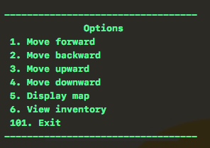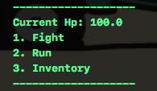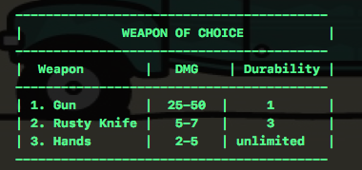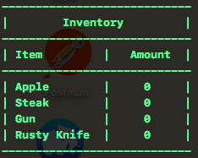

**What** will the user interface for your game look like? Show me.

* The user interface will show the map of where the user is currently located with a question of what the user would like to do.

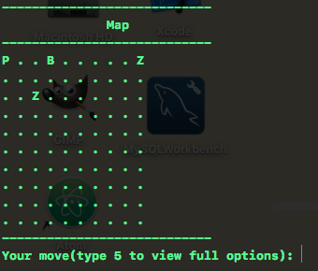­

**What** data will be saved in one or more files? List the data elements.

* The data that will be saved is the user position as well as the layout of the map.

**What** are the rules for your game? List them.

* Cannot step over boundaries.
* Cannot go through walls.
* Cannot go through doors that are locked unless they have a key.
* Cannot use gun once they have run out of bullets.
* Cannot use knife when durability is 0.

**What** does the player have to do to win? List the winning criteria.

* Player has to gain all the keys to unlock doors to new mazes
* Finds the winning chalices to complete the quest.

**What** does the player have to do to lose the game? List the ways they can lose.

* Player will have to lose all hp.

**What** data does the program keep from session to session? Show me the list.

* Bullet Count
* Knife Durability
* Player HP
* Player Position
* Zombie(s) Position(s)
* Apple Count
* Steak Count

**What** data is saved for high scores? Show how it will look to the user.

* Still under discussion

**What**will the user have to do to keep their own data? Will they have to sign in? Show how that will look.

* User will have to enter a username and (maybe) password.
* Under Discussion

Tell me **Who** is going to code the menuing system.

* Controls (Andrew)
* Fighting (Andrew)
* Door opening (Andrew)
* Inventory (Andrew)
* Encountering a fight (Andrew)
* Save Menu (Sean)
* Map Design (Sean)

Tell me **Who** is going to code the file IO.

* Sean

Tell me **Who** is going to code each part of the game.

* Player Movement (Andrew)
* Fights (Andrew)
* Player Options (Andrew)
* Zombie Movement (Sean)
* Map Design (Sean & Andrew)
* Saving Game (Sean)
* Saving New Users (Sean)